# 1. Linux operating system and memory hierarchy

1.1 Open a terminal, run the command ”Top”, and save a screenshot in your report.

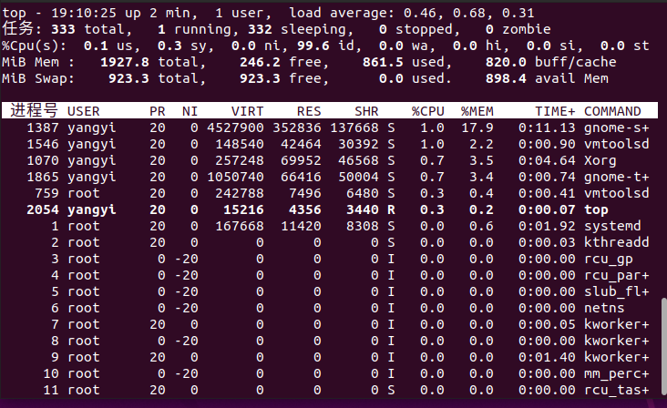

1.2 Use a few Linux commands to collect the hardware information of your computer to draw the memory hierarchy diagram (see Lecture 1). List the used commands and briefly explain what they are used for.

lscpu:显示关于CPU架构的详细信息，包括核心数量、线程、CPU型号等

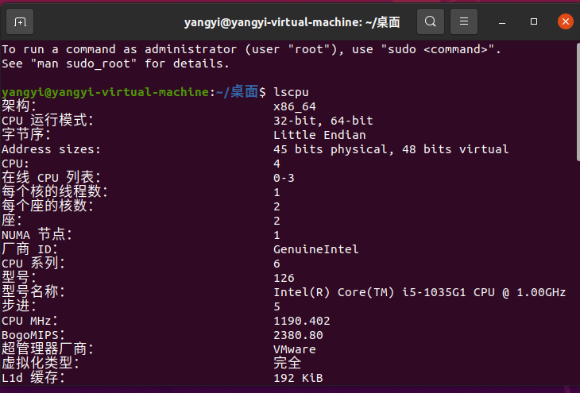

free -h:显示系统中已用和可用内存的情况，包括RAM和交换内存，输出为人类可读格式。

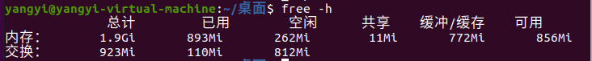

lsblk:列出所有块设备（如硬盘和SSD）及其分区，提供设备名称、大小和类型的信息。

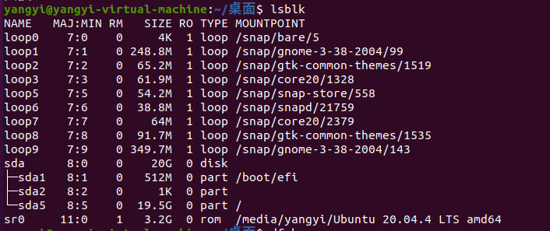

Df -h:报告文件系统的磁盘空间使用情况，显示已用空间和可用空间

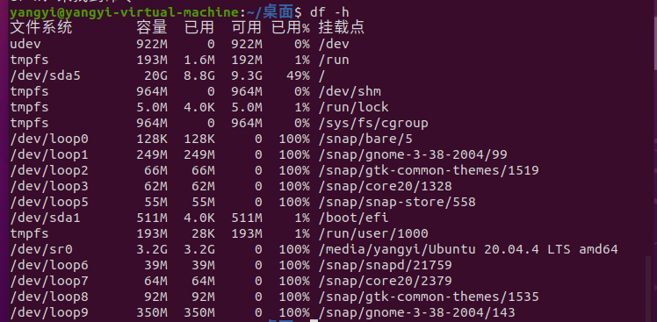

1.3 Install the Linux ”tree” command if your Linux system does not have it, e.g.,

sudo apt install tree

Run the commands: cd /var; tree | tail -n 60

Paste the output into your report and briefly explain what these commands did.

Answer:

* Install the linux ‘tree’:

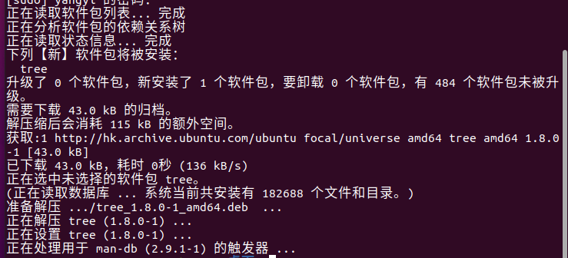

* Run the commands: cd /var; tree | tail -n 60

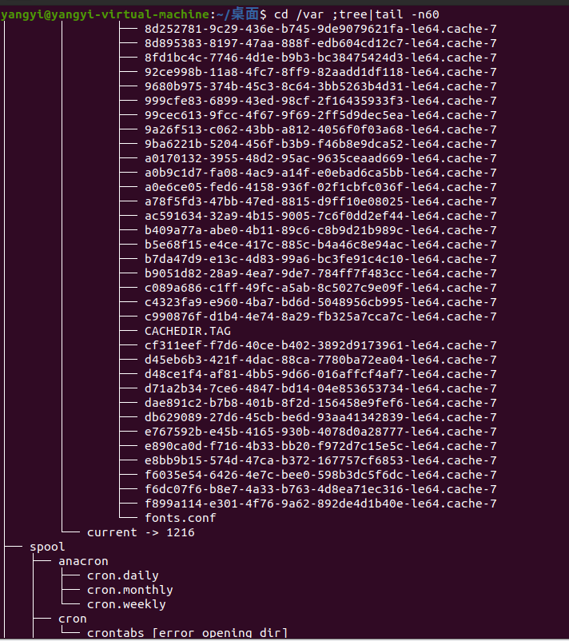

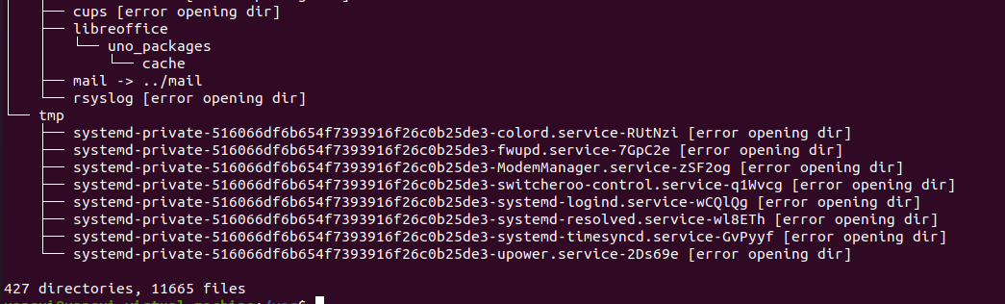

* Explain the command

切换到 /var 目录。使用 tree 命令查看该目录的结构。仅显示输出的最后 60 行，方便用户查看。

# Bash script

generate a text file

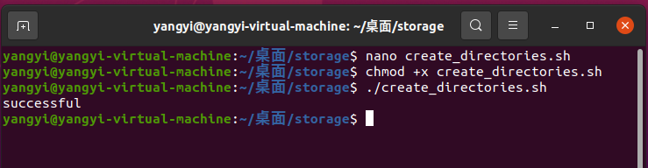

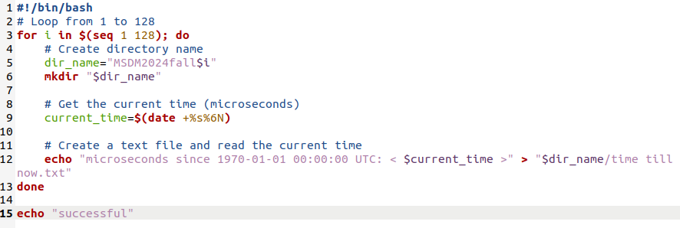

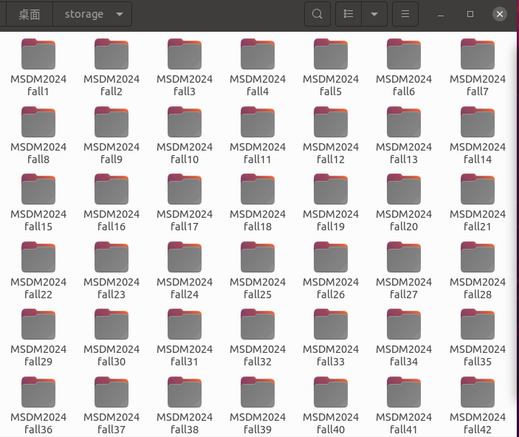

一次性查看所有目录中的 time till now.txt 文件

